Задача 19. Найти производную второго порядка 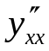 от функции, заданной параметрически.
19.1. 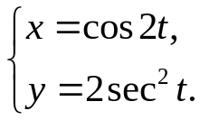
x'= -2sin2t= -4sintcost
y'= 4sint/cos³t
y''_{xx}= 4sint = -1 _
16sin²tcos⁵t 4sintcos⁵t
19.2. 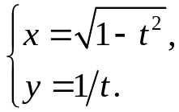
x'= -t/√(1-t²)
y'= -1/t²
y''_{xx}= (1-t²)² t⁴
19.3. 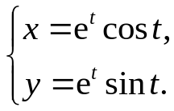
x'= e^{t}cost-e^{t}sint= e^{t}(cost-sint)
y'= e^{t}sint+e^{t}cost= e^{t}(sint+cost)
y''_{xx}= e^{t}(sint+cost) = sint+cost
e^{2t}(cost-sint)² e^{t}(cost-sint)²
19.4. 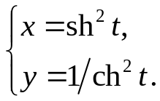
x'= 2shtcht
y'= -2sht/ch³t
y''_{xx}= -2sht = -1_
4shtch⁴t 2ch⁴t
19.5. 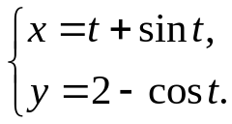
x'= 1+cost
y'= sint
y''_{xx}= sint/(1+cost)²
19.6. 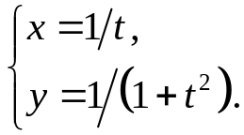
x'= -1/t²
y'= -2t/(1+t²)²
y''_{xx}= -2t³ _
(1+t²)²
19.7. 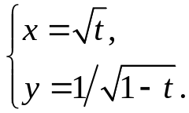
x'= 1/2√t
y'= 1/√(1-t)³
y''_{xx}= 4t _
√(1-t)³
19.8. 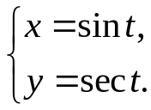
x'= cost
y'= sint/cos²t
y''_{xx}= sint/cos⁴t
19.9. 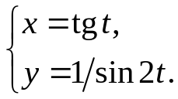
x'= 1/cos²t
y'= -2cos2t/sin²2t
y''_{xx}= -2cos2tcos⁴t
sin²2t
19.10. 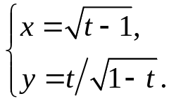
x'= 1/2√(t-1)
y'= (2-t)/(1-t)^{3/2}
y''_{xx}= 4(t-1)(2-t) = 2t-8
(1-t)^{3/2} √(1-t)
19.11. 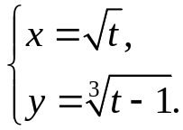
x'= 1/2√t
y'= 1/³√(t-1)²
y''_{xx}= 4t/³√(t-1)²
19.12. 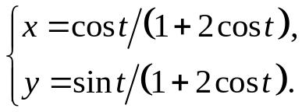
x'= -sint/(1+2cost)²
y'= (cost+2)/(1+2cost)²
y''_{xx}= (cost+2)(1+2cost)⁴ = (cost+2)(1+2cost)²
sin²t(1+2cost)² sin²t
19.13. 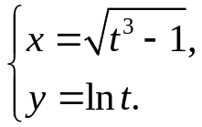
x'= 3t² / 2√(t³-1)
y'= 1/t
y''_{xx}= 2(t³-1)
3t⁵
19.14. 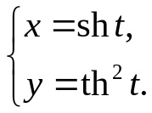
x'= cht
y'= 2tht/ch²t
y''_{xx}= 2tht/ch⁴t
19.15. 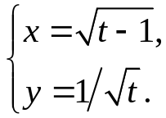
x'= 1/2√(t-1)
y'= -1/2√t³
y''_{xx}= -2t+2
√t³
19.16. 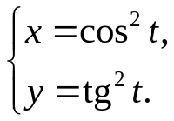
x'= -2cost sint
y'= 2sint/cos³t
y''_{xx}= 2sint = 1/2cos⁴t
4cos⁴tsint
19.17. 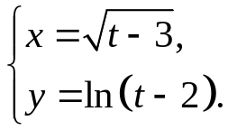
x'= 1/2√(t-3)
y'= 1/(t-2)
y''_{xx}= 4(t-3)/(t-2)
19.18. 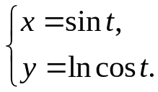
x'= cost
y'= -sint/cost
y''_{xx}= -sint/cos³t
19.19. 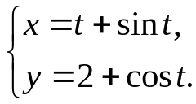
x'= 1+cost
y'= -sint
y''_{xx}= -sint/(1+cost)²
19.20. 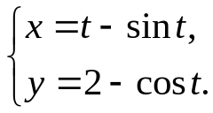
x'= 1-cost
y'= sint
y''_{xx}= sint/(1-cost)²
19.21. 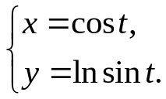
x'= -sint
y'= cost/sint
y''_{xx}= -cost/sin³t
19.22. 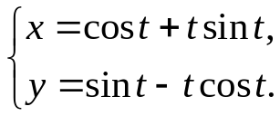
x'= -sint+sint+tcost= tcost
y'= cost-cost+tsint= tsint
y''_{xx}= sint/cos²t
19.23. 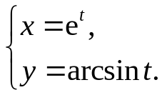
x'= e^{t}
y'= 1/√(1-t²)
y''_{xx}= e^{t}/√(1-t²)
19.24. 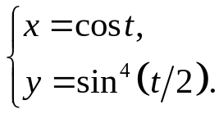
x'= -sint
y'= 2sin3(t/2)cos(t/2)
y''_{xx}= -2sin³(t/2)cos(t/2)/sint= -sin²(t/2)
19.25. 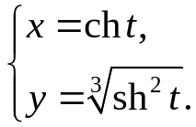
x'= sht
y'= 2cht/3³√sht
y''_{xx}= 2cht/3³√sh⁴t
19.26. 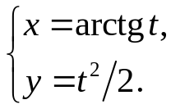
x'= 1/(1+t²)
y'= t
y''_{xx}= t(1+t²)²
19.27. 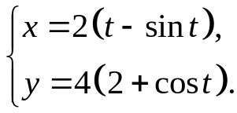
x'= 2-2cost
y'= -4sint
y''_{xx}= -2sint/(1-cost)
19.28. 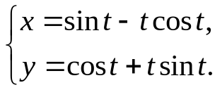
x'= cost-cost+tsint= tsint
y'= -sint+sint+tcost= tcost
y''_{xx}= cost/sin²t
19.29. 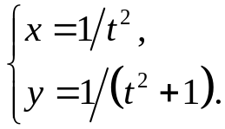
x'= -2/t³
y'= -2t/(t²+1)²
y''_{xx}= -t⁷/2(t²+1)²
19.30. 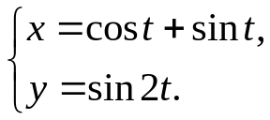
x'= cost-sint
y'= 2cos2t
y''_{xx}= 2cos2t/( cost-sint)= 2cost+2sint
19.31. 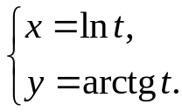
x'= 1/t
y'= 1/(1+t²)
y''_{xx}= t²/(1+t²)

